Ex No: 1 A IMPLEMENTATION OF BRESENHAM’S ALGORITHM FOR LINES
Date:

AIM:

To write a C Program for implementing Bresenham’s algorithm for line drawing

ALGORITHM:
- Start
- Read the two end points of the line and assign the left end point to x₀ ,y₀
- Load x₀ ,y₀ into the frame buffer (i.e) plot the first point
- Compute dx,dy,2dy and 2dy-2dx and determine the decision parameter P₀ as 2dy-dx
- At each x_{k} , along the line starting at k = 0, perform the following test
- If P_{k} < 0, the next point to plot is (x_{k+1} , y_{k} ) and P_{k+1} = P_{k} +2dy
- Otherwise the next point to plot is (x_{k} , y_{k+1} ) and P_{k+1} = P_{k} +2dy- 2dx
6. Repeat step 4 dx times
7. Stop

Program:
#include<stdio.h>
#include<conio.h>
#include<math.h>
#include<graphics.h>
void main()
{
int gd=DETECT,gm;
int dx,dy,p,end;
float x1,x2,y1,y2,x,y;
initgraph(&gd,&gm,"");
printf("\nEnter the value of x1: ");
scanf("%f",&x1);
printf("\nEnter the value of y1: ");
scanf("%f",&y1);
printf("\nEnter the value of x2: ");
scanf("%f",&x2);
printf("\nEnter the value of y2: ");
scanf("%f",&y2);
dx=abs(x1-x2);
dy=abs(y2-y1);
p=2*dy-dx;
if(x1>x2)
{
x=x2;
y=y2;
end=x1;
}
else
{
x=x1;
y=y1;
end=x2;
}
putpixel(x,y,10);
while(x<end)
{

x=x+1;
if(p<0)
{
p=p+2*dy;
}
else
{
y=y+1;
p=p+2*(dy-dx);
}
putpixel(x,y,10);
}
getch();
closegraph();
}
Output:
C:\c.j.raman>
Enter the value of x1: 100
Enter the value of y1: 100
Enter the value of x2: 200
Enter the value of y2: 200
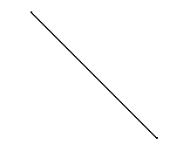
Result:
Thus a C Program to implement Bresenham’s algorithm for drawing a line was written and executed.

Ex No: 1B IMPLEMENTATION OF BRESENHAM’S ALGORITHM FOR CIRCLE

Date:

AIM:
To write a C Program for implementing Bresenham’s algorithm for circle drawing.

ALGORITHM:
- Start
- Input the radius r and the center (x_{c},y_{c}) and obtain the first point on the circumference of a circle centered on the origin as (x₀,y₀) = (0,r)
- Calculate the initial value of the decision parameter as P₀ = 5/4 – r
- At each x_{k} position, starting at k = 0, perform the following test
- If P_{k} < 0, the next point along the circle centered on (0,0) is (x_{k+1},y_{k}) and P_{k+1} = P_{k} +2x_{k+1}+1
- Otherwise, the next point along the circle is (x_{k+1},y_{k-1}) and P_{k+1} = P_{k} +2x_{k+1}+1- 2y_{k+1} where 2x _{k+1} = 2x _{k} + 2 and 2y_{k+1} = 2y _{k} - 2
- Determine symmetry points in the remaining seven octants
- Move each calculated pixel position (x,y) onto the circular path centered on (x_{c},y_{c}) and plot the coordinate value x = x+x_{c} , y = y+ y_{c}
- Repeat steps 3 to 5 until x >= y
- Stop

Program:
#include<stdio.h>
#include<conio.h>
#include<graphics.h>
#include<math.h>

void main()
{
int xc, yc, x, y, p[100], r, k;
int gdriver=DETECT, gmode, errorcode;
printf("\nEnter the center point(xc,yc): ");
scanf("%d%d", &xc, &yc);
printf("\nEnter the radius: ");
scanf("%d", &r);
printf("\nPlotting...\n");
sleep(5);
clrscr();

initgraph(&gdriver, &gmode, "");
p[0]=1-r;
x=0;
y=r;
for(k=0;k<=y;k++)
{
putpixel(xc+x, yc+y, 9);
putpixel(xc-x, yc-y, 9);
putpixel(xc+x, yc-y, 9);
putpixel(xc-x, yc+y, 9);
putpixel(xc+y, yc+x, 9);
putpixel(xc-y, yc-x, 9);
putpixel(xc+y, yc-x, 9);
putpixel(xc-y, yc+x, 9);
if(p[k]>0)
{
p[k+1]= p[k]+ 2*(x+1)+1-2*(y+1);
x++;
y--;
}
else
{
p[k+1]=p[k]+2*(x+1)+1;
x++;
}
}
getch();
}

Output:
C:\c.j.raman>
Enter the center point(xc,yc): 100 100
Enter the radius: 50
Plotting...

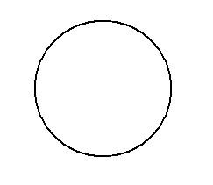

Result:
Thus a C Program to implement Bresenham’s algorithm for drawing a circle was written and executed.

Ex No: 1C IMPLEMENTATION OF BRESENHAM’S ALGORITHM FOR ELLIPSE

Date:

AIM:
To write a C Program for implementing Bresenham’s algorithm for ellipse drawing.

ALGORITHM:

- Start
- Input a, b and ellipse center (x_{c}, y_{c}) and obtain the first point on the ellipse centered on the origin as (x₀, y₀) = (0,b)
- Calculate the initial value of the decision parameter in region 1 as P1₀ = b² – a²b + ¼ a²
- At each x_{k} position in region 1, starting at k = 0, perform the following test
- If P1_{k} < 0, the next point along the ellipse centered on (0,0) is (x_{k+1,}y_{k}) and P1_{k} = P1_{k} + 2b²x_{k+1}+b²
- Otherwise , the next point along the circle is (x_{k+1,}y_{k-1}) and P1_{k} = P1_{k} + 2b²x_{k+1} – 2a²y_{k+1}+b² with 2b²x_{k+1} = 2b²y_{k} – 2a² and continue until 2b²x >= 2a²y
- Calculate the initial value of the decision parameter in region 2 using the last point (x₀, y₀) calculated in region 1 as P2₀ = b²(x₀+1/2)² +a²(y₀-1)² – a²b²
- At each y_{k} position in region 2, starting at k = 0, perform the following test
- If P2_{k} > 0 , the next point along the ellipse centered (0,0) is (x_{k,}y_{k-1}) and P2_{k+1} = P2_{k} – 2a²y_{k+1}+b²
- Otherwise , the next point along the circle is (x_{k+1,}y_{k-1}) and P2_{k+1} = P2_{k} + 2b²x_{k+1} – 2a²y_{k+1}+a² using the same incremental calculation for x and y in region 1.
- Determine symmetry points in the other three quadrants
- Move each calculated pixel position (x,y) onto the elliptical path centered on (x_{c}, y_{c}) and plot the coordinate values x = x + x_{c} and y = y + y_{c}
- Repeat the steps 4 to 8 until 2b²x >= 2a²y
- Stop

Program:
#include<stdio.h>
#include<conio.h>
#include<graphics.h>
#include<math.h>
float x,y;
int xc,yc;
void disp();
void main()
{
int gd=DETECT, gm;
int a,b;
float p1,p2;
clrscr();
initgraph(&gd,&gm,"");
printf("Enter the co-ordinate (xc,yc,a,b): ");
scanf("%d %d %d %d",&xc,&yc,&a,&b);
cleardevice();
x=0.0;
y=b;
p1=(b*b)-(a*a*b)+((a*a)/4.0);
while((2.0*b*b*x)<=(2.0*a*y*a))
{
x++;
if(p1<=0)
p1=p1+(2.0*b*b*x)+(b*b);
else
{
y--;
p1=p1+(2.0*b*b*x)+(b*b)-(2.0*a*a*y);
}
disp();
}
//region2
x=a;
y=0.0;

p2=((b*b)/4.0)+(a*b*b)+(a*a);
while((2.0*b*b*x)>(2.0*a*a*y))
{
y++;
if(p2>0)
p2=p2+(a*a)-(2.0*a*a*y);
else
{
x--;
p2=p2+(2.0*b*b*x)+(a*a)-(2.0*a*a*y);
}
disp();
}
getch();
closegraph();
}
void disp()
{
putpixel(xc+x,yc+y,1);
putpixel(xc-x,yc+y,1);
putpixel(xc+x,yc-y,1);
putpixel(xc-x,yc-y,1);
}
Output:

Enter the co-ordinate (xc,yc,a,b): 100 100 100 81

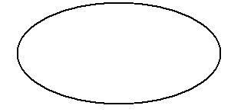
Result:
Thus a C Program to implement Bresenham’s algorithm for drawing an ellipse was written and executed.

EX NO 2 Implementation of Line, Circle and ellipse Attributes

Date:

AIM:

To write a program to draw a Line,circle,ellipse.

ALGORITHM

Step 1: Start

Step 2: Draw the line. Set the attributes like style,type,width etc.
Step 3: Draw the circle. Set the attributes using commands.

Step 4: Draw the ellipse . Set the attributes like fillcolour,fillstyle,linecolour,linewidth
Step 5: stop the program

Program:

#include<graphics.h>
#include<stdlib.h>
#include<stdio.h>
#include<conio.h>
int userpat;
char *name[]={"SOLID_LINE","DOTTED_LINE","CENTER_LINE","DASHED_LINE","USER BIT_LINE"};
int main(void)
{
int gdriver=DETECT,gmode,errorcode;
int midx,midy,i;
int xradius=100,yradius=100,choice,userpat;
int style;
initgraph(&gdriver,&gmode,"Z:\\TC\\BGI");
errorcode=graphresult();
if(errorcode!=grOk)
{
printf("graphics error %s \n",grapherrormsg(errorcode));
printf("press any key to halt:");
getch();
exit(1);
}
midx=getmaxx()/2;
midy=getmaxy()/2;
do{
printf("\n Enter 1.circle 2.Ellipse 3.Line");
printf("\n Enter choice");
scanf("%d",choice);
switch(choice)
{
case 1:
for
(i=EMPTY_FILL;i<USER_FILL;i++)
{

setfillstyle(i,getmaxcolor());
fillellipse(midx,midy,xradius,yradius);
getch();
cleardevice();
}
break;
case 2:
exit(1);
break;
case 3:
userpat=1;
for(style=SOLID_LINE;style<=USER_FILL;style++)
{
setlinestyle(style,userpat,1);
line(0,0,midx-10,midy);
getch();
cleardevice();
}
}
}
while(choice!=0);
closegraph();
return 0;
}

Output:
ENTER 1.CIRCLE 2.ELLIPSE 3.LINE

ENTER CHOICE 1:

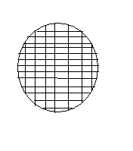

ENTER CHOICE 2:

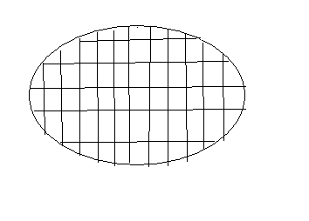

ENTER CHOICE 3:

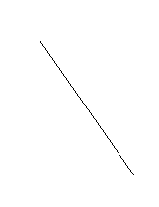

Result:
Thus a C program to perform implementation of line,Circle and Ellipse Attributes was written and executed.
Ex No: 3 2D-TRANSFORMATION

Date:

AIM:

To write a C program to perform 2D basic transformations such as translation, rotation, scaling, shearing and reflection.

ALGORITHM:
- Start
- Read the coordinate values to draw the 2D figure and perform the following steps to achieve the necessary transformations
- Translation : Read the translation vector t_{x} and t_{y} and compute the new position using x₁ = x + t_{x} , y₁ = y + t_{y} and display the new position
- Rotation : Read the rotation angle Θ and compute the new position using the formula x₁ = x Cos Θ – y Sin Θ , y₁ = x Sin Θ + y Cos Θ and display the new position
- Scaling : Read the scaling factor s_{x} and s_{y} and compute the new position using x₁ = x. s_{x} , y₁ = y. s_{y} and display the new position
- Shearing : Shearing is done in x direction and y direction using the factor sh_{x} and sh_{y} for X direction: x₁ = x + sh_{x} (y – yref), y₁ = y & for Y direction x₁ = x , y₁ = sh_{y} (x – xref)
- Reflection : Reflkection depends upon the reflection axis . If reflection axis is y = x , then x₁ = y and y₁ = x
- Stop

Program:

#include<stdio.h>
#include<conio.h>
#include<math.h>
#include<graphics.h>

int i,pt[8]={50,50,150,50,150,100,50,50};

void trans();
void scale();
void reflect();
void shear();
void rotate();

void main()
{
int gd=DETECT,gm;
int refpt[2]={100,100};
initgraph(&gd,&gm," ");
setbkcolor(WHITE);
setcolor(BLUE);

for(i=0;i<7;i++)
{
drawpoly(4,pt);
}
trans();
shear();
scale(refpt);
reflect();
rotate(refpt);
closegraph();
}

void trans()
{
int p[8];
int i,tx=0,ty=150;
printf("Translation");
for(i=0;i<8;i=i+2)
{
p[i]=pt[i]+tx;
p[i+1]=pt[i+1]+ty;
}
drawpoly(4,pt);
drawpoly(4,p);
getch();
cleardevice();
}
void scale(int ref[])
{
int p[8],i;
float sx=2.0,sy=2.0;
printf("\t SCALING: ");
for(i=0;i<8;i=i+2)
{
p[i]=ref[0]+(pt[i]-ref[0])*sx;
p[i+1]=ref[1]+(pt[i+1]-ref[1])*sy;
}
drawpoly(4,pt);
drawpoly(4,p);
getch();
cleardevice();
}
void shear()
{
int p[8];
int i,shx=2,shy=2,xref=50,yref=50;
printf("\t\t\t X direction shear w.r.t y reference\n");
for(i=0;i<8;i=i+2)
{

p[i]=pt[i]+(pt[i+1]-yref)*shx;
p[i+1]=pt[i+1];

}
line(0,yref,639,yref);
drawpoly(4,pt);
drawpoly(4,p);
getch();
cleardevice();
setcolor(8);
printf("\t\t\t Y direction shear w.r.t x reference\n");
for(i=0;i<8;i=i+2)
{
p[i]=pt[i];
p[i+1]=pt[i+1]+(pt[i]-xref)*shy;
}
line(xref,0,xref,479);
drawpoly(4,pt);
drawpoly(4,p);
getch();
cleardevice();
}
void reflect()
{
int p[8],i;
printf("\t\t Reflection w.r.t line x=y\n");
for(i=0;i<8;i=i+2)
{
p[i]=pt[i+1];
p[i+1]=pt[i];
}
setcolor(3);
drawpoly(4,pt);
drawpoly(4,p);
getch();
cleardevice();
}

void rotate(int ref[])
{
int p[8];

int a,i;
float r;
printf("\t\t\tRotation\n");
printf("\tEnter the Degree to rotate the object: ");
scanf("%d",&a);
r=(a*(3.14/180));
setcolor(6);
for(i=0;i<8;i=i+2)
{
p[i]=ref[0]+((pt[i]-ref[0])*(cos(r))-((pt[i+1]-ref[1])*(sin(r))));
p[i+1]=ref[1]+((pt[i]-ref[0])*(sin(r))+((pt[i+1]-ref[1])*(cos(r))));

}
drawpoly(4,pt);
drawpoly(4,p);
getch();
cleardevice();
}

Output:
C:\c.j.raman>
Translation
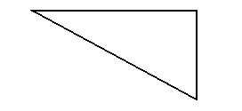

X direction Shearing w.r.t Y reference
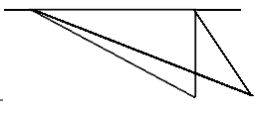
Y direction Shearing w.r.t X reference

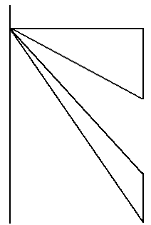

Scaling:
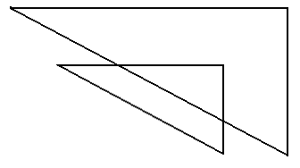

Reflection:
w.r.t line x=y

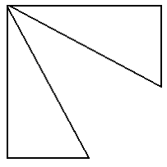
Rotation:
Enter the Degree to rotate the object: 270
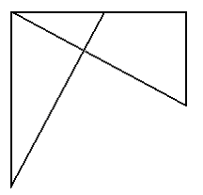

Result:

Thus a C program to perform 2D basic transformations such as translation, rotation, scaling, shearing and reflection was written and executed.

Ex No: 4 COMPOSITE 2D-TRANSFORMATION

Date:

AIM:
To write a C program to perform 2D composite transformations.

ALGORITHM:
- Start
- Read the coordinate values to draw the 2D figure and perform the following steps to achieve the necessary composite transformations
- Translation : Read the translation vector t_{x} and t_{y} and compute the new position using x₁ = x + t_{x} , y₁ = y + t_{y} and display the new position
- Scaling : Read the scaling factor s_{x} and s_{y} and compute the new position using x₁ = x. s_{x} , y₁ = y. s_{y} and display the new position
- InverseTranslation : Use the translation vector t_{x} and t_{y} and compute the new position using x₁ = x - t_{x} , y₁ = y - t_{y} and display scaled figure in its original position (i.e) the initial position before translation
- Stop

Program:

#include<stdio.h>
#include<conio.h>
#include<math.h>
#include<graphics.h>
inti,j,pt[8]={100,100,200,100,200,150,100,100};
void trans();
void scale();
void shear();
void rotate();
void reflect();
void main()
{
intgd=DETECT,gm;
intrefpt[2]={100,100};
initgraph(&gd,&gm,"");
setbkcolor(WHITE);
setcolor(RED);
for(i=0;i<7;i++)
{
drawpoly(4,pt);
}
trans();
shear();
scale(refpt);
reflect();
rotate(refpt);
closegraph();
}
void trans()
{
int p[8],p1[8];
inti,j,tx=0,ty=150;
printf("\n\t\tTranslation......");
for(i=0;i<8;i=i+2)
{

p[i]=pt[i]+tx;
p[i+1]=pt[i+1]+ty;
}
for(j=0;j<8;j=j+2)
{
p1[j]=p[j]+150;
p1[j+1]=p[j+1]+0;
}
setcolor(BLUE);
drawpoly(4,p1);
setcolor(GREEN);
drawpoly(4,pt);
setcolor(YELLOW);
drawpoly(4,p);
getch();
cleardevice();
}
void scale(int ref[])
{
int p[8],p1[8],i,j;
float sx=2.0,sy=2.0;
printf("\n\t\tScaling......");
for(i=0;i<8;i=i+2)
{
p[i]=ref[0]+(pt[i]-ref[0])*sx;
p[i+1]=ref[1]+(pt[i+1]-ref[1])*sy;
}
for(j=0;j<8;j++)
{
p1[j]=ref[0]+(p[j]-ref[0])*sx;
p1[j+1]=ref[1]+(p[j+1]-ref[1])*sy;
}
setcolor(BLUE);
drawpoly(4,p1);
setcolor(GREEN);
drawpoly(4,pt);
setcolor(YELLOW);

drawpoly(4,p);
getch();
cleardevice();
}
void shear()
{
int p[8],p1[8];
inti,shx=2,shy=2,xref=100,yref=100;
printf("\n\tX direction shear with respect to Y reference");
for(i=0;i<8;i=i+2)
{
p[i]=pt[i]+(pt[i+1]-yref)*shx;
p[i+1]=pt[i+1];
}
for(j=0;j<8;j=j+2)
{
p1[j]=p[j]+(p[j+1]-yref)*shx;
p1[j+1]=p[j+1];
}
line(0,yref,639,yref);
setcolor(BLUE);
drawpoly(4,p1);
setcolor(GREEN);
drawpoly(4,pt);
setcolor(YELLOW);
drawpoly(4,p);
getch();
cleardevice();
setcolor(8);
printf("\n\tY direction shear with respect to X reference");
for(i=0;i<8;i=i+2)
{
p[i]=pt[i];
p[i+1]=pt[i+1]+(pt[i]-xref)*shy;
}
for(j=0;j<8;j=j+2)
{

p1[j]=p[j]+(p[j+1]-yref)*shx;
p1[j+1]=p[j+1];
}
line(xref,0,xref,479);
setcolor(BLUE);
drawpoly(4,p1);
setcolor(GREEN);
drawpoly(4,pt);
setcolor(YELLOW);
drawpoly(4,p);
getch();
cleardevice();
}
void reflect()
{
int p[8],p1[8],i,j;
printf("\n\tReflection with respect to x=y\n");
for(i=0;i<8;i=i+2)
{
p[i]=pt[i+1];
p[i+1]=pt[i];
}
for(j=0;j<8;j=j+2)
{
p1[j]=-p[j]+200;
p1[j+1]=-p[j+1]+200;
}
setcolor(BLUE);
drawpoly(4,p1);
setcolor(GREEN);
drawpoly(4,pt);
setcolor(YELLOW);
drawpoly(4,p);
getch();
cleardevice();
}

void rotate(int ref[])
{
int p[8],p1[8],a,i,j;
float r;
printf("\n\tRotation\n");
printf("\nEnter the degree to rotate the diag\n");
scanf("%d",&a);
r=(a*(3.14/180));
setcolor(6);
for(i=0;i<8;i=i+2)
{
p[i]=ref[0]+((pt[i]-ref[0])*(cos(r))-((pt[i+1]-ref[1])*sin(r)));
p[i+1]=ref[1]+((pt[i]-ref[0])*(sin(r))+((pt[i+1]-ref[1])*cos(r)));
}
for(j=0;j<8;j=j+2)
{
p1[j]=ref[0]+((p[j]-ref[0])*(cos(r))-((p[j+1]-ref[1])*sin(r)));
p1[j+1]=ref[1]+((p[j]-ref[0])*(sin(r))+((p[j+1]-ref[1])*cos(r)));
}
setcolor(BLUE);
drawpoly(4,p1);
setcolor(GREEN);
drawpoly(4,pt);
setcolor(YELLOW);
drawpoly(4,p);
getch();
cleardevice();
}

Output:
TRANSLATION:

X DIRECTION SHEAR WITH RESPECT TO Y REFERENCE:

Y DIRECTION SHEAR WITH RESPECT TO X REFERENCE:

SCALING:

REFLECTION WITH RESPECT TO LINE X=Y:

ROTATION:
Enter The Direction Of Rotation:90

Result:
Thus a C program to perform 2D composite transformations was written and executed.

Ex No: 5 IMPLEMENTATION OF COHEN SUTHERLAND LINE CLIPPING AND WINDOW TO VIEWPORT TRANSFORMATION

Date:

AIM:

To write a C program to implement Cohen Sutherland line clipping algorithm and to perform window to viewport transformation.

ALGORITHM:
Line Clipping:

- Start
- Read the rectangular frame coordinates values rx₁ , ry₁, rx₂, ry₂
- Read the line coordinate(x,y)
- Find the slope of the line and the corresponding intersection values with the rectangular frames
- Clip the portion of the line which lies outside the rectangular frame and retain the portion of the line that lies inside the rectangular frame
- Stop

Window to Viewport Transformation:

- Start
- Assign the viewport coordinates in the variables v₁, v₂, v₃, v₄
- To perform transformation use the corresponding line coordinates
- Determine the scaling factors using the formula s_{x} = v₃- v₁ / rx₂ – rx₁ & s_{y} = v₄- v₂ / ry₂ – ry₁
- Map the line to the viewport using the line coordinate and the scaling factors
- Display the viewport
- Stop

Program:
#include<stdio.h>
#include<conio.h>
#include<graphics.h>
#include<math.h>
void clip(float ,float,float);
void mapping();
int i,j=0,n;
int rx1,rx2,ry1,ry2;
float x1[8],y1[8];
void main()
{
int gd=DETECT,gm;
int i,n;
float x[8],y[8],m;
clrscr();
initgraph(&gd,&gm,"");
printf("Enter the co-ordinates of rectangle:");
scanf("%d%d%d%d",&rx1,&ry1,&rx2,&ry2);
n=2;
printf("Co-ordinates: ");
for(i=0;i<n;i++)
scanf("%f%f",&x[i],&y[i]);
cleardevice();
outtextxy(10,10,"Before cliping");
outtextxy(10,470,"Press any key.....");
rectangle(rx1,ry1,rx2,ry2);
for(i=0;i<n-1;i++)
line(x[i],y[i],x[i+1],y[i+1]);
line(x[i],y[i],x[0],y[0]);
getch();
cleardevice();
for(i=0;i<n-1;i++)
{
m=(y[i+1]-y[i])/(x[i+1]-x[i]);

clip(x[i],y[i],m);
}
clip(x[i],y[i],m);
outtextxy(10,10,"After cliping");
outtextxy(10,470,"Press any key.....");
rectangle(rx1,ry1,rx2,ry2);
for(i=0;i<j-1;i++)
line(x1[i],y1[i],x1[i+1],y1[i+1]);
getch();
printf("\tWindow to view port mapping");
mapping();
for(i=0;i<j-1;i++)
line(x1[i],y1[i],x1[i+1],y1[i+1]);
getch();
}
void clip(float e,float f,float m)
{
if(e<rx1)
{
f+=m*(rx1-e);
e=rx1;
}
else if(e>rx2)
{
f+=m*(rx2-e);
e=rx2;
}
if(f<ry1)
{
e+=(ry1-f)/m;
f=ry1;
}
else if(f>ry2)
{
e+=(ry2-f)/m;
f=ry2;

}
x1[j]=e;
y1[j]=f;
j++;
}
void mapping()
{ float sx,sy;
int i,n=1,v1,v2,v3,v4;
v1=425;
v2=75;
v3=550;
v4=250;

sx=(float)(v3-v1)/(rx2-rx1);
sy=(float)(v4-v2)/(ry2-ry1);

rectangle(v1,v2,v3,v4);
for(i=0;i<=n;i++)
{
x1[i]=v1+floor(((float)(x1[i]-rx1)*sx)+0.5);
y1[i]=v2+floor(((float)(y1[i]-ry1)*sy)+0.5);
}
}
Output:
Enter the co-ordinates of rectangle: 200 200 400 400
Co-ordinates: 250 350 450 350
Before Clipping…..
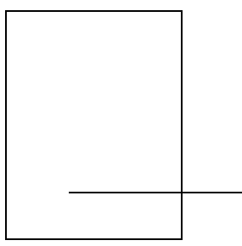
Press any key……..
After Clipping……

Press any key……..
Window to view port mapping
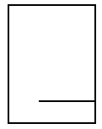

Result:
Thus a C program to implement Cohen Sutherland line clipping algorithm and to perform window to viewport transformation was written and executed.
Ex No: 6 IMPLEMENTATION OF SUTHERLAND – HODGEMAN POLYGON
CLIPPING ALGORITHM

Date:

AIM:
To write a C program to implement Sutherland – Hodgeman Polygon clipping algorithm.

ALGORITHM:

- Start
2. Get the minimum and maximum coordinates of both window and view port.
3. Get the number of sides of a polygon and its corresponding coordinates.
4. If the polygon lies within region code window, display it.
5. If any one of the polygon side is neither inside nor outside the boundary, find the point of intersection and clip the regions that lies outside the boundary.
6. Display the polygon after clipping
7. Stop

Program:

#include<stdio.h>
#include<graphics.h>
#include<math.h>
typedef struct
{
float x;
float y;
}PT;
int n;
main()
{
int i,j,gd,gm;
PT d,p1,p2,p[20],pi1,pi2,pp[20];
detectgraph(&gd,&gm);
initgraph(&gd,&gm," ");

/* Read coordinates of clipping window */
printf("Enter coordinates (left,top) of point1 : ");
scanf("%f %f",&p1.x,&p1.y);
printf("Enter coordinates (right,bottom) of point2 : ");
scanf("%f %f",&p2.x,&p2.y);
/* Enter the number of vertex */
printf("Enter the number of vertex : ");
scanf("%d",&n);
/* Read vertex coordinates of clipping window */
for(i=0;i<n;i++)
{
printf("Enter coordinates of vertex%d : ",i+1);
scanf("%f %f",&p[i].x,&p[i].y);
}
p[i].x = p[0].x;
p[i].y = p[0].y;
cleardevice();
drawpolygon(p,n);
rectangle(p1.x,p1.y,p2.x,p2.y);

getch();
left(p1,p,pp);
right(p2,p,pp);
top(p1,p,pp);
bottom(p2,p,pp);
cleardevice();
rectangle(p1.x,p1.y,p2.x,p2.y);
drawpolygon(p,n);
getch();
closegraph();
}

left(PT p1,PT p[20],PT pp[20])
{
int i,j=0;
for(i=0;i<n;i++)
{
if(p[i].x < p1.x && p[i+1].x >= p1.x)
{
if(p[i+1].x-p[i].x!=0)
{
pp[j].y = (p[i+1].y-p[i].y)/(p[i+1].x-p[i].x)* (p1.x-p[i].x)+p[i].y;
}
else
{
pp[j].y = p[i].y;
}
pp[j].x = p1.x;
j++;
pp[j].x=p[i+1].x;
pp[j].y=p[i+1].y;
j++;
}
if(p[i].x > p1.x && p[i+1].x >= p1.x)
{
pp[j].y = p[i+1].y;

pp[j].x = p[i+1].x;
j++;
}
if(p[i].x > p1.x && p[i+1].x <= p1.x)
{
if(p[i+1].x-p[i].x!=0)
{
pp[j].y = (p[i+1].y-p[i].y)/(p[i+1].x-p[i].x)* (p1.x-p[i].x)+p[i].y;
}
else
{
pp[j].y = p[i].y;
}
pp[j].x = p1.x;
j++;
}
}
for(i=0;i<j;i++)
{
p[i].x = pp[i].x;
p[i].y = pp[i].y;
}
p[i].x = pp[0].x;
p[i].y = pp[0].y;
n=j;
}

right(PT p2,PT p[20],PT pp[20])
{
int i,j=0;
for(i=0;i<n;i++)
{
if(p[i].x > p2.x && p[i+1].x <= p2.x)
{
if(p[i+1].x-p[i].x!=0)
{
pp[j].y = (p[i+1].y-p[i].y)/(p[i+1].x-p[i].x)* (p2.x-p[i].x)+p[i].y;

}
else
{
pp[j].y = p[i].y;
}
pp[j].x = p2.x;
j++;
pp[j].x=p[i+1].x;
pp[j].y=p[i+1].y;
j++;
}
if(p[i].x < p2.x && p[i+1].x <= p2.x)
{
pp[j].y = p[i+1].y;
pp[j].x = p[i+1].x;
j++;
}
if(p[i].x < p2.x && p[i+1].x >= p2.x)
{
if(p[i+1].x-p[i].x!=0)
{
pp[j].y = (p[i+1].y-p[i].y)/(p[i+1].x-p[i].x)* (p2.x-p[i].x)+p[i].y;
}
else
{
pp[j].y = p[i].y;
}
pp[j].x = p2.x;
j++;
}
}
for(i=0;i<j;i++)
{
p[i].x = pp[i].x;
p[i].y = pp[i].y;
}

p[i].x = pp[0].x;
p[i].y = pp[0].y;
n=j;
}

top(PT p1,PT p[20],PT pp[20])
{
int i,j=0;
for(i=0;i<n;i++)
{
if(p[i].y < p1.y && p[i+1].y >= p1.y)
{
if(p[i+1].y-p[i].y!=0)
{
pp[j].x = (p[i+1].x-p[i].x)/(p[i+1].y-p[i].y)* (p1.y-p[i].y)+p[i].x;
}
else
{
pp[j].x = p[i].x;
}
pp[j].y = p1.y;
j++;
pp[j].x=p[i+1].x;
pp[j].y=p[i+1].y;
j++;
}
if(p[i].y > p1.y && p[i+1].y >= p1.y)
{
pp[j].y = p[i+1].y;
pp[j].x = p[i+1].x;
j++;
}
if(p[i].y > p1.y && p[i+1].y <= p1.y)
{
if(p[i+1].y-p[i].y!=0)
{

pp[j].x = (p[i+1].x-p[i].x)/(p[i+1].y-p[i].y)* (p1.y-p[i].y)+p[i].x;
}
else
{
pp[j].x = p[i].x;
}
pp[j].y = p1.y;
j++;
}
}
for(i=0;i<j;i++)
{
p[i].x = pp[i].x;
p[i].y = pp[i].y;
}
p[i].x = pp[0].x;
p[i].y = pp[0].y;
n=j;

}
bottom(PT p2,PT p[20],PT pp[20])
{
int i,j=0;
for(i=0;i<n;i++)
{
if(p[i].y > p2.y && p[i+1].y <= p2.y)
{
if(p[i+1].y-p[i].y!=0)
{
pp[j].x = (p[i+1].x-p[i].x)/(p[i+1].y-p[i].y)* (p2.y-p[i].y)+p[i].x;
}
else
{
pp[j].x = p[i].x;
}
pp[j].y = p2.y;
j++;

pp[j].x=p[i+1].x;
pp[j].y=p[i+1].y;
j++;
}
if(p[i].y < p2.y && p[i+1].y <= p2.y)
{
pp[j].y = p[i+1].y;
pp[j].x = p[i+1].x;
j++;
}
if(p[i].y < p2.y && p[i+1].y >= p2.y)
{
if(p[i+1].y-p[i].y!=0)
{
pp[j].x = (p[i+1].x-p[i].x)/(p[i+1].y-p[i].y)* (p2.y-p[i].y)+p[i].x;
}
else
{
pp[j].x = p[i].x;
}
pp[j].y = p2.y;
j++;
}
} for(i=0;i<j;i++)
{
p[i].x = pp[i].x;
p[i].y = pp[i].y;
}
p[i].x = pp[0].x;
p[i].y = pp[0].y;
n=j;
}
drawpolygon(PT x[20],int n)
{
int i;

for(i=0;i<n-1;i++)
{
line(x[i].x,x[i].y,x[i+1].x,x[i+1].y);
}
line(x[i].x,x[i].y,x[0].x,x[0].y);
}

Output:
ENTER COORDINATES (LEFT,TOP) OF POINT1:100
200
ENTER COORDINATES (RIGHT,BOTTOM) OF POINT2:300
400
enter the number of vertex:3
enter the coordinates of vertex 1:303
404
enter the coordinates of vertex 2:202
101
enter the coordinates of vertex 3:303
101

Result:
Thus a C program to implement Sutherland – Hodgeman Polygon clipping algorithm was written and executed.

Ex No: 7 3D TRANSFORMATIONS

Date:

AIM:

To write a C program to perform 3D transformations.

ALGORITHM:
- Start
- Get the coordinate values for the 3D shape
- Draw the figure and perform the following transformations
- Translation: To perform translation read the translation factors t_{x}, t_{y} and t_{z} and compute the new coordinate values as x₁ = x + t_{x} , y₁ = y + t_{y} and z₁ = z + t_{z}
- Scaling: to perform scaling read the corresponding scaling factors s_{x}, s_{y} and s_{z} and compute the new coordinate values.
- Rotation: To perform rotation read the rotation angle Θ and the reference axis .
For X axis rotation
x₁ = x
y₁ = y Cos Θ – z Sin Θ
z₁ = y Sin Θ + z Cos Θ
For Y axis rotation
x₁ = z Sin Θ + x Cos Θ
y₁ = y
z₁ = z Cos Θ – x Sin Θ
For Z axis rotation
x₁ = x Cos Θ – y Sin Θ
y₁ = y Sin Θ + x Cos Θ
z₁ = z
- Redraw the 3D figure using the coordinates x₁, y₁ , z₁
- Stop

Program:

#include<stdio.h>
#include<conio.h>
#include<math.h>
#include<graphics.h>
void draw(int[4][4],int);
void trans();
void rot();
void scal();
void main()
{
int c;
do
{
printf("\n1.translation\n2.rotation\nscaling\n4.exit");
printf("\nenter ur choice:");
scanf("%d",&c);
switch(c)
{
case 1:
trans();
break;
case 2:
rot();
break;
case 3:
scal();
break;
case 4:
exit();
break;
}
}while(c<=4);
}
void trans()
{
int gd=DETECT,gm;
int a[4][4],b[4][4],t[4][4],x[4][4],y[4][4];
int n=4,i,j,k,tx=100,ty=100,tz=100,depth=20;
float th=60.0;
initgraph(&gd,&gm,"");
for(i=0;i<4;i++)
{
for(j=2;j<4;j++)
a[i][j]=1;
}
for(i=0;i<4;i++)
{
for(j=0;j<2;j++)
{
printf("\nenter the points %d %d:",i,j);
scanf("%d",&a[i][j]);
}}
th=th*(3.14/180);
draw(a,n);
getch();
for(i=0;i<n;i++)
{
x[i][0]=a[i][0]+(depth*cos(th));
x[i][1]=a[i][1]+(depth*sin(th));
line(a[i][0],a[i][1],x[i][0],x[i][1]);
}
getch();
draw(x,n);
getch();
for(i=0;i<4;i++)
{
for(j=0;j<4;j++)
{
if(i==j)
t[i][j]=1;
else
t[i][j]=0;
}}

t[3][0]=tx;
t[3][1]=ty;
t[3][2]=tz;
for(i=0;i<4;i++)
{
for(j=0;j<4;j++)
{
b[i][j]=0;
for(k=0;k<4;k++)
b[i][j]+=a[i][k]*t[k][j];
}}
for(i=0;i<4;i++)
{
y[i][0]=b[i][0]+(depth*cos(th));
y[i][1]=b[i][1]+(depth*sin(th));
line(b[i][0],b[i][1],y[i][0],y[i][1]);
}
getch();
draw(y,n);
getch();
draw(b,n);
getch();
closegraph();
}
void rot()
{
int gd=DETECT,gm;
int a[4][4],b[4][4],x[4][4],y[4][4],t[4][4];
int n=4,i,j,k,depth=20;
float s[4][4];
float th=60.0,th1=15.0;
initgraph(&gd,&gm,"");
for(i=0;i<4;i++)
{
for(j=0;j<2;j++)
a[i][j]=1;

}
for(i=0;i<4;i++)

{
for(j=0;j<2;j++)
{
printf("\nenter the points %d %d:",i,j);
scanf("%d",&a[i][j]);
}
}
th=th1*(3.14/180);
draw(a,n);
getch();
for(i=0;i<n;i++)
{
x[i][0]=a[i][0]+(depth*cos(th));
x[i][1]=a[i][1]+(depth*sin(th));
line(a[i][0],a[i][1],x[i][0],x[i][1]);
}
getch();
draw(x,n);
getch();
for(i=0;i<4;i++)
for(j=0;j<4;j++)
{
if(i==j)
s[i][j]=1.0;
else
s[i][j]=0.0;
}
th1=th1*(3.14/180);
draw(a,n);
s[0][0]=cos(th1);
s[0][1]=sin(th1);
s[1][0]=sin(th1);
s[1][1]=cos(th1);
for(i=0;i<4;i++)

for(j=0;j<4;j++)
{
b[i][j]=0;

for(k=0;k<3;k++)
b[i][j]+=(int)a[i][k]*s[k][j];
}
for(i=0;i<4;i++)
{
y[i][0]=b[i][0]+(depth*cos(th));
y[i][1]=b[i][1]+(depth*sin(th));
line(b[i][0],b[i][1],y[i][0],y[i][1]);
}
getch();
draw(y,n);
getch();
draw(b,n);
getch();
closegraph();
}
void scal()
{
int gd=DETECT,gm;
int a[4][4],b[5][4],s[4][4],x[4][4],y[4][4];
int n=4,i,j,k,depth=20;
float th=60.0,th1=30.0,sx=2.0,sy=2.0,sz=2.0;
initgraph(&gd,&gm,"");
for(i=0;i<4;i++)
{
for(j=0;j<2;j++)
a[i][j]=1;
}
for(i=0;i<4;i++)
{
for(j=0;j<2;j++)
{
printf("\nenter the points %d %d:",i,j);

scanf("%d",&a[i][j]);
}}
th=th1*(3.14/180);
draw(a,n);
getch();
for(i=0;i<n;i++)
{x[i][0]=a[i][0]+(depth*cos(th));
x[i][1]=a[i][1]+(depth*sin(th));
line(a[i][0],a[i][1],x[i][0],x[i][1]);
}
getch();
draw(x,n);
getch();
for(i=0;i<4;i++)
{
for(j=0;j<4;j++)
{
if(i==j)
s[i][j]=1.0;
else
s[i][j]=0.0;
}}
th1=th1*(3.14/180);
s[0][0]=sx;
s[1][1]=sy;
s[2][2]=sz;
for(i=0;i<4;i++)
{
for(j=0;j<4;j++)
{
b[i][j]=0;
for(k=0;k<4;k++)
b[i][j]+=(int)(a[i][k]*s[k][j]);
}}
for(i=0;i<4;i++)
{

y[i][0]=b[i][0]+(depth*cos(th));
y[i][1]=b[i][1]+(depth*sin(th));
line(b[i][0],b[i][1],y[i][0],y[i][1]);
}
getch();
draw(y,n);

getch();
draw(b,n);
getch();
closegraph();
}
void draw(int d[4][4],int nx)
{
int i;
for(i=0;i<nx;i++)
{
line(d[i][0],d[i][1],d[i+1][0],d[i+1][1]);
line(d[nx-1][0],d[nx-1][1],d[0][0],d[0][1]);
}
}

Output:

1.Translation
2.Rotation
3.Scaling
4.Exit
Enter your choice:1

Enter the points 0 0:200
Enter the points 0 1:200
Enter the points 1 0:250
Enter the points 1 1:200
Enter the points 2 0:250
Enter the points 2 1:250
Enter the points 3 0:200
Enter the points 3 1:250

1.Translation
2.Rotation
3.Scaling
4.Exit

Enter your choice:2

Enter the points 0 0:200
Enter the points 0 1:200
Enter the points 1 0:250
Enter the points 1 1:200
Enter the points 2 0:250
Enter the points 2 1:250
Enter the points 3 0:200
Enter the points 3 1:250

1.Translation
2.Rotation
3.Scaling
4.Exit

Enter your choice:3
Enter the points 0 0:200
Enter the points 0 1:200
Enter the points 1 0:250
Enter the points 1 1:200
Enter the points 2 0:250
Enter the points 2 1:250
Enter the points 3 0:200
Enter the points 3 1:250

1.Translation
2.Rotation
3.Scaling
4.Exit
Enter your choice:4

Result:
Thus a C program to perform 3D transformations was written and executed.

Ex. No: 8 COMPOSITE 3D TRANSFORMATION
Date:

AIM:

To write a program to perform composite 3D Transformation.

Composite transformation:

Here we multiply the matrix representations for the individual operations in the transformation sequence. This concatenation is carried out from right to left. A sequence of 3 basic transformation is carried out to produce the composite transformation

ALGORITHM

- Translation

  - A point is transferred from position (x,y,z) to position (x1,y1,z1) with
the matrix operation
X1 | 1 0 0 |  |  | tx | x
Y1 = | 0 1 0 ty |  |  |  | y
Z1 | 0 0 1 tz |  |  |  | z
1 | 0 | 0 | 0 | 1 | 1
  - The values are x1=x+tx ,y1=y+ty and z1=z+tz.

- Rotation

  - Coordinate axes rotation

X1=x-cos θ-ysin θ
Y1=xsin θ+ycos θ
Z1=z
- Y axis rotation
Z1=zcos θ-xsin θ X1=zsin θ+xcos θ

Y1=y

- X axis rotation

Y1=ycos θ-zsin θ
Z1=ysin θ+zcos θ
X1=x
- Scaling
  - Translate the fixed point to the origin

  - Scale the object

  - Translate the fixed point back to its original position

- Finally display the object after the sequence of transformation

Program:

#include <stdio.h>
#include <stdlib.h>
#include<graphics.h>
#include<conio.h>
void draw3d(int fs,int x[20],int y[20],int tx,int ty,int d);
void draw3d(int fs,int x[20],int y[20],int tx,int ty,int d)
{
int i,j,k=0;
for(j=0;j<2;j++)
{
for(i=0;i<fs;i++)
{
if(i!=fs-1)
line(x[i]+tx+k,y[i]+ty-k,x[i+1]+tx+k,y[i+1]+ty-k);
else
line(x[i]+tx+k,y[i]+ty-k,x[0]+tx+k,y[0]+ty-k);
}
k=d;
}
for(i=0;i<fs;i++)
{
line(x[i]+tx,y[i]+ty,x[i]+tx+d,y[i]+ty-d);
}
}

void main()
{
int gd=DETECT,gm;
int x[20],y[20],tx=0,ty=0,i,fs,d;
initgraph(&gd,&gm,"Z:\\TC\\BGI");
printf("No of sides (front view only) : ");
scanf("%d",&fs);
printf("Co-ordinates : ");
for(i=0;i<fs;i++)
{
printf("(x%d,y%d)",i,i);
scanf("%d%d",&x[i],&y[i]);
}
printf("Depth :");
scanf("%d",&d);
draw3d(fs,x,y,tx,ty,d);
getch();//front view
setcolor(14);
for(i=0;i<fs;i++)
{
if(i!=fs-1)
line(x[i]+200,y[i],x[i+1]+200,y[i+1]);
else
line(x[i]+200,y[i],x[0]+200,y[0]);
}
getch();//top view

for(i=0;i<fs-1;i++)
{
line(x[i],300,x[i+1],300);
line(x[i],300+d*2,x[i+1],300+d*2);
line(x[i],300,x[i],300+d*2);
line(x[i+1],300,x[i+1],300+d*2);
}
getch();//side view
for(i=0;i<fs-1;i++)
{
line(10,y[i],10,y[i+1]);
line(10+d*2,y[i],10+d*2,y[i+1]);
line(10,y[i],10+d*2,y[i]);
line(10,y[i+1],10+d*2,y[i+1]);
}
getch();
closegraph();
}

Output:
NO:OF:SIDES(FRONT VIEW ONLY): 4
CO-ORDINATES: (X0,Y0):50 50
(X1,Y1):100 100
(X2,Y2):150 150
(X3,Y3):200 200
DEPTH: 500

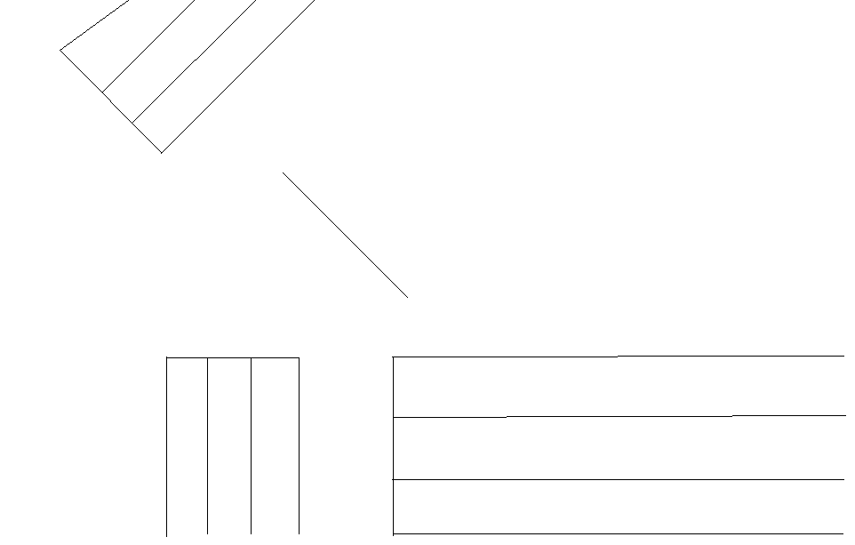

Result:
Thus a C program to perform 3D composite transformations was written and executed.

Ex No: 9 DRAWING THREE DIMENSIONAL OBJECTS

Date:

AIM:

To draw a three dimensional snow man using blender.

ALGORITHM:

Procedure:
Step 1:Open up blender.
You will see a screen with a box, camera and a lamp
Step 2: hit "A" key to unselect all, and hit "A" again to select all! then hit "X" key and delete all objects.
Step 3: ok we start making the body of your snowman, add a UVSphere.
that is Space bar ---> Add ---> Mesh ---> UVSphere
Step 4: you will see a ball at your screen now, this is our snowmans body.
select it by right-clicking it and hit "S" key (Scale).
Step 5: before you start scaling hold down "CTRL" then scale. scale it bigger 8 times, when you hold down ctrl it scales a little bit everytime you move the mouse.
now you should have something like this:
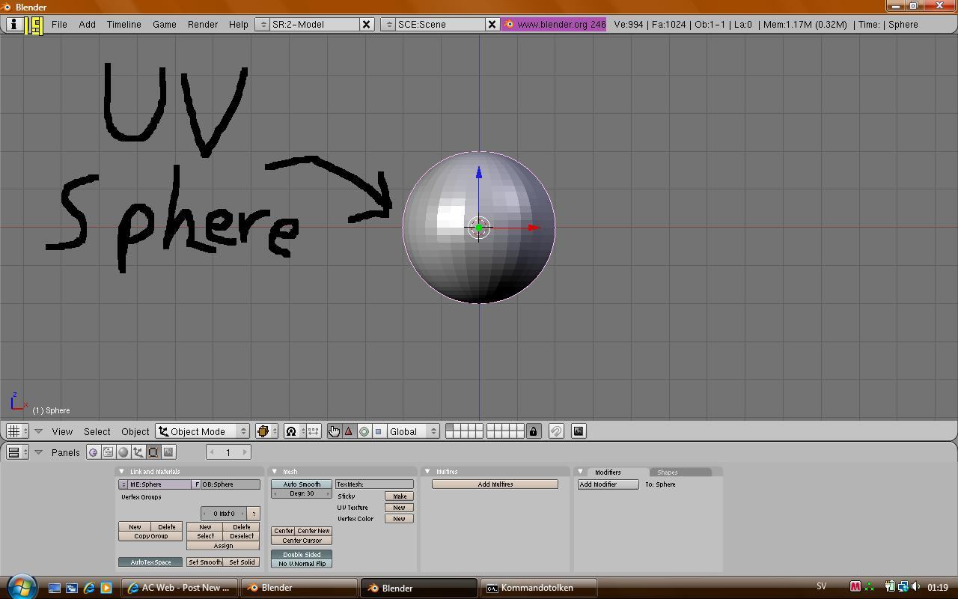
step 6: now we make it white.
at the bottom of blender you have the panels bar
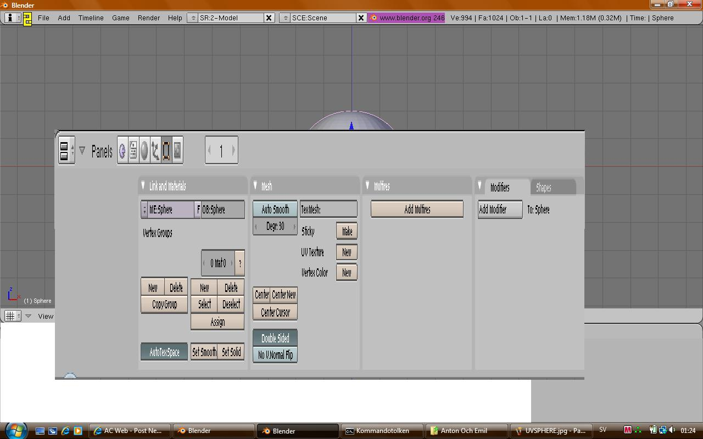
step 7: see the "link and Materials" window, find "set smooth" there, hit it!
your sphere will now look more smooth
step 8: at the top of your panels bar you see
Panels [Packman Icon] [A txt paper] [a ball] [three arrows] [a square] [and a image icon], hit the "ball" icon that says "shading" or just hit F5!
step 9: hit "add new"
step 10: at the Material window you see alots of buttons and below that you see 3 bars that says R, G and B. this is the color. to make it a snow color set all R G and B to 1, the highest!
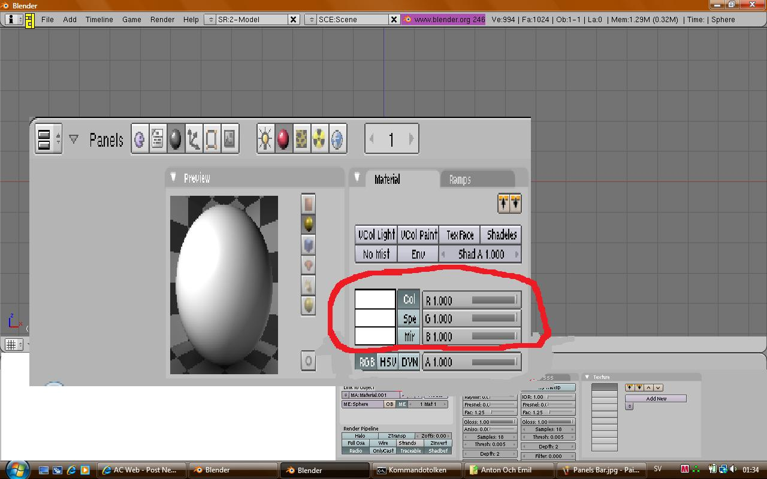
right of the "Material" Window you'll see the "Link and Pipelines" Window, there, change the "link to object" MA: Material.001 to white or snow or w/e.
we will need this later
step 11: right of "link and pipelines" window you see the "shaders" window, if the shaders window is not selected just select it by hitting it.
set ref to 1.000
spec to 2.000
and hard to 1
your sphere should now be white.
now the body is done!
Part 2, making the head!
step 1: unselect the body, by hitting the "A" key (select/unselect all)
Step 2: hit Space Bar ---> add ---> Mesh ---> UVSphere
Do not scale this sphere
before you move it make sure Num Lock is enabled then hit Num Pad 1! it takes you to the front view.
step 3: select the head, press "G" key to grab it, and place it at the top of your snowman body, so it looks like this:
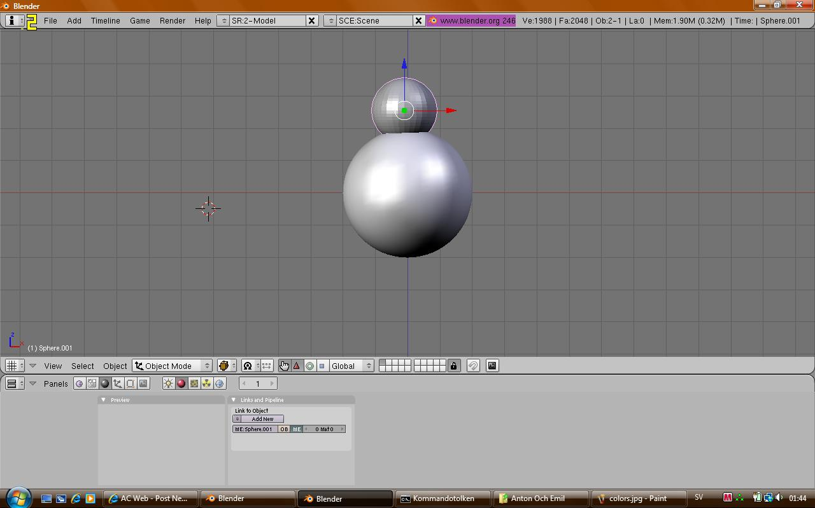
step 4: set the head smooth then hit F5.
step 5: instead of hitting " Add New" hit the browse arros left of "add new", select the snow material you created before.
step 6: now, hit "A" key to unselect all, then hit it again to select all, hit ctrl+j and select "Join selected meshes".
now your snowman head and body is one object
step 7: add > Mesh > UVSphere, scale it smaller 9 times.
step 8: hit Num Pad 3 to go into side view and place the small uvsphere so it looks like this:
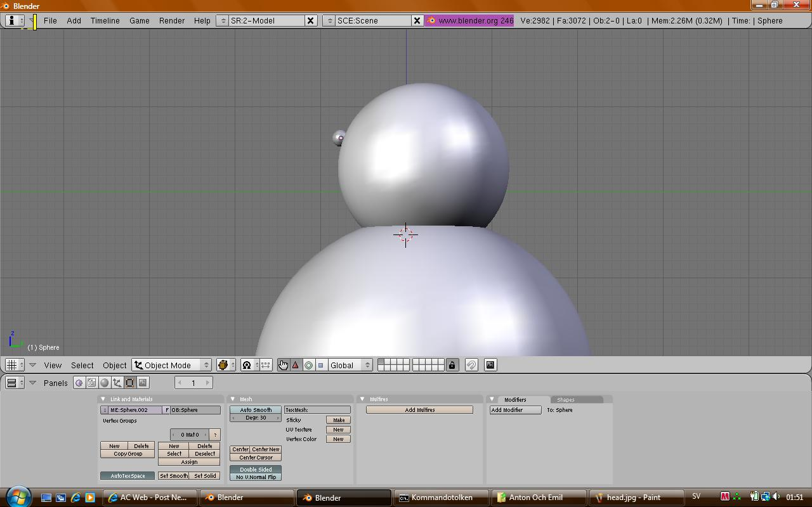
step 9: go into front view (num pad 1) and select the small sphere
step 10: place it at your snowmans head so it looks like to be his eye
step 11: select the eye and hit Shift+D to copy it
place it right of the other eye, so it looks like that he have 2 eyes!
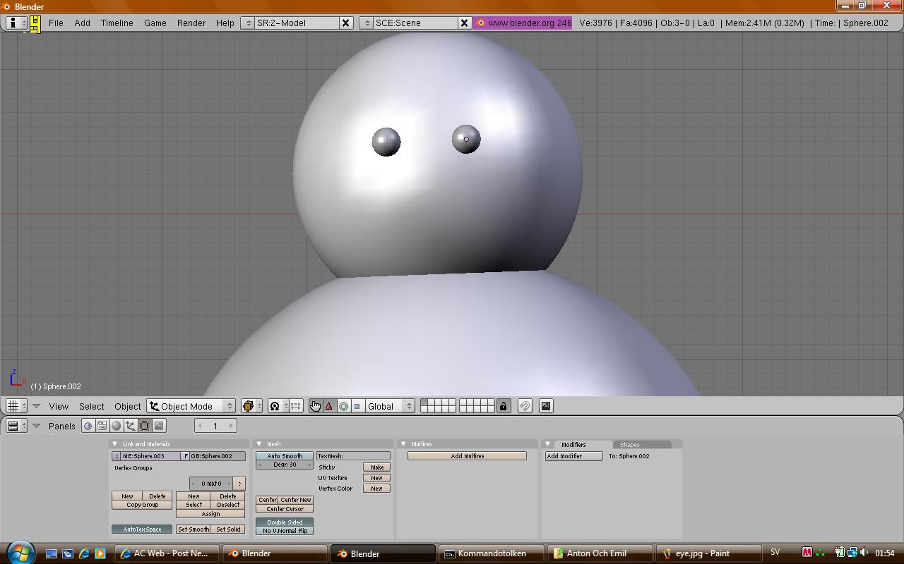

step 12: now go into side view (num pad 3)
step 13: space bar > add > mesh > cone
step 14: select the cone and hit "R" key to rotate it, rotate it so it could be the nose of your snowman
step 15: hit ctrl+alt+S, to advance scale it, scale it till it looks like the desired size.

Result:

Thus a three dimensional snowman was created using blender.

Ex No: 10 GENERATING FRACTAL IMAGES

Date:

AIM:

To create a fantastic landscape using Modifier and Bump-map.

ALGORITHM:
Use two image-textures to create the landscape.The first texture – Bump-map for making relief; the second texture – for color.
1.Creation of Bump-map
To start the creation of Bump-map we should follow the steps given below:
- Fire up Gimp by double clicking its icon or running it from the command line.
- Create file 1024x1024 with white background.
- Then carry out the following actions: Filters >> Render >> Fractal Exrlorer >> Fractals >> Explosive >> Apply >> OK.
- We'll invert the received image: Colors >> Invert.
- Our image needs some color correction: Colors >> Levels >> Auto >> OK. That's all. The Bump-map is ready :-) (fig.1).
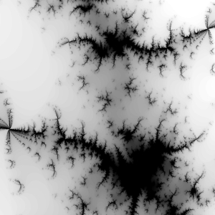
Figure 1
The Bump-map is ready.

2.Assigning Bump-map to a plane in Blender
- Fire up Blender,
- Change to the top view with «NUM7»
- Add a plane, subdivide it several times (in the attached .blend file the amount of vertices is not sufficient – this is made to reduce the file's size).
- Go to Buttons Window, add material to the plane (Material buttons F5) and add Bump-texture,
- Disable the received texture channel (click on the tick) as this texture serves only for creation of relief.
- With plane still selected select the Editing context (F9) and add necessary Modifier, in our case it is Displase.
- Write in the name of our Bump-map in the option «Texture».
- Look attentively at the name of the texture in the texture channel ( we'll see that the name contains not only extension, but «I.» before the name of texture itself (for ex., I.BumpMap.jpg))
- Edit the value in the option «Strength», fill in this option, (for example, -0.2500. )
- Press «Apply», then smooth the received mesh, simply press the button «Set Smooth» in the «Link and Materials» panel.
- Pay attention, that white parts of Bump-map are stretching upwards, and black parts – downwards; also it is necessary to remember that extruding depends on the normals' direction.
- The mesh is ready.
Sculpt Mode
To eliminate defects activate Sculpt Mode (fig.2) and we'll see that in the context Editing (F9) two new tabs appeared, «Sculpt» and «Brush».
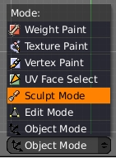
Figure 2

At first work with options that are situated in the «Sculpt» tab (fig.3). Smooth the tops of our mountains. press the «Smooth» button and set values for options «Size» and «Strength», the size of our
brush will be, for example, 50, and strength – 40. If the tool doesn't work swimmingly,it means that the amount of vertices is not sufficient. In «Multires» tag, press the «Apply Multires» button. 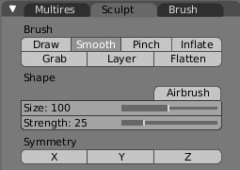
Figure 3
After having smoothed the top of our mountains it is recommended to add some ridges where it is necessary. In the tab «Brush» (fig.4) press on the free texture channel, press «Add New», select the Texture Buttons (F6) to add a texture for our brush.
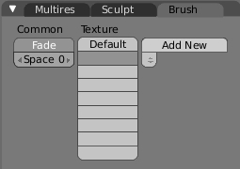
Figure 4
There's a row of buttons near the «Preview» panel (in the left), activate the «Brush» button and choose the «Noise» texture. Assign the texture and return to the context «Editing» (F9). In the «Sculpt» tab, activate the following buttons: «Draw», «Add» or «Sub» or «Airbrush», set parameters for options «Size» and «Strength» and draw some small exavations on the mesh (fig.5).

Aim:
To create a fantastic landscape using Modifier and Bump-map.
Procedure:
Use two image-textures to create the landscape.The first texture – Bump-map for making relief; the second texture – for color.
1.Creation of Bump-map
To start the creation of Bump-map we should follow the steps given below:
- Fire up Gimp by double clicking its icon or running it from the command line.
- Create file 1024x1024 with white background.
- Then carry out the following actions: Filters >> Render >> Fractal Exrlorer >> Fractals >> Explosive >> Apply >> OK.
- We'll invert the received image: Colors >> Invert.
- Our image needs some color correction: Colors >> Levels >> Auto >> OK. That's all. The Bump-map is ready :-) (fig.1).
Figure 1
The Bump-map is ready.

2.Assigning Bump-map to a plane in Blender
- Fire up Blender,
- Change to the top view with «NUM7»
- Add a plane, subdivide it several times (in the attached .blend file the amount of vertices is not sufficient – this is made to reduce the file's size).
- Go to Buttons Window, add material to the plane (Material buttons F5) and add Bump-texture,
- Disable the received texture channel (click on the tick) as this texture serves only for creation of relief.
- With plane still selected select the Editing context (F9) and add necessary Modifier, in our case it is Displase.
- Write in the name of our Bump-map in the option «Texture».
- Look attentively at the name of the texture in the texture channel ( we'll see that the name contains not only extension, but «I.» before the name of texture itself (for ex., I.BumpMap.jpg))
- Edit the value in the option «Strength», fill in this option, (for example, -0.2500. )
- Press «Apply», then smooth the received mesh, simply press the button «Set Smooth» in the «Link and Materials» panel.
- Pay attention, that white parts of Bump-map are stretching upwards, and black parts – downwards; also it is necessary to remember that extruding depends on the normals' direction.
- The mesh is ready.
Sculpt Mode
To eliminate defects activate Sculpt Mode (fig.2) and we'll see that in the context Editing (F9) two new tabs appeared, «Sculpt» and «Brush».
Figure 2
At first work with options that are situated in the «Sculpt» tab (fig.3). Smooth the tops of our mountains. press the «Smooth» button and set values for options «Size» and «Strength», the size of our brush will be, for example, 50, and strength – 40. If the tool doesn't work swimmingly,it means that the amount of vertices is not sufficient. In «Multires» tag, press the «Apply Multires» button.
Figure 3
After having smoothed the top of our mountains it is recommended to add some ridges where it is necessary. In the tab «Brush» (fig.4) press on the free texture channel, press «Add New», select the Texture Buttons (F6) to add a texture for our brush.
Figure 4
There's a row of buttons near the «Preview» panel (in the left), activate the «Brush» button and choose the «Noise» texture. Assign the texture and return to the context «Editing» (F9). In the «Sculpt» tab, activate the following buttons: «Draw», «Add» or «Sub» or «Airbrush», set parameters for options «Size» and «Strength» and draw some small exavations on the mesh (fig.5).
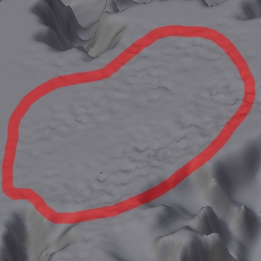
Figure 5
The model of the landscape is ready. Only to set parameters for lighting and material left (the settings are in the attached .blend file). As for material settings, use Ramps (fig.6), procedural texture «Noise» and seamless color image-texture, that you can see having unpacked the .blend file.
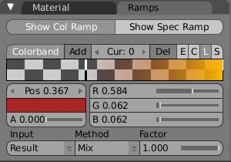
Figure 6
Also World, Ambient Occlusion, Mist were added. The mist in our case is used for creation of transparency. To render transparency, but not the mist, press the «RGBA» button that is in the «Scene» context (F10) on the «Format» panel, and choose the appropriate format that supports transparency (for ex., .tga). This is made for easy correction and easy replacement of background color. To correct final Render «Node Editor» was used (for details see tutorial «Editing of Objects' Materials and Render Results by Means of Node Editor»). To render color corrections that were made in «Node Editor» I activated the «Do Composite» button (fig.7), that can be found in the «Scene» context (F10) in the «Animation» panel.

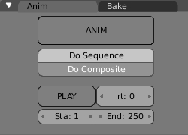
Figure 7
The work in Blender editor is completed, but yet another one is waiting for us :
Image's Correction in Gimp (or PhotoShop).
- Open the rendered image in Gimp (PhotoShop).
- Add new white-colored layer and lower it to bottom.
- Copy the layer with our landscape and activate the «Overlay» mode for this layer.
- Copy the layer with the landscape again, raise the layer to top and activate the «Dodge» mode, the level of opacity should be 50 for this layer.
- Now merge the image.
- For better result we can copy the received layer and activate «Burn» mode for our copied layer, the level of opacity approximately – 10 or 24.
- If necessary add brightness, contrast.
The fantastic landscape is ready for a book-cover (fig.8).
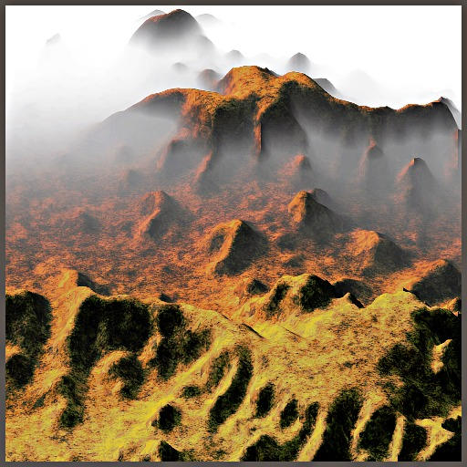
Figure 8

Result:
Thus a fractal image was created using blender.

VIVA Questions
- ----------are visual presentations on some surface, such as a wall, canvas, computer screen, paper, or stone to brand, inform, illustrate, or entertain.
- Graphics can be -------- or ----------.
- ---------generally involves making marks on a surface by applying pressure from a tool, or moving a tool across a surface.
- The main techniques used in drawing are --------,---------,-------,-------, and -------
- ----------is a sub-field of computer science which studies methods for digitally synthesizing and manipulating visual content.
- ---------, --------,--------,and --------- are some of the applications of computer graphics.
- -------,------,------and ------- are some of the connected studies of Computer graphics.
- ------- studies ways to represent and process surfaces.
- ------- studies with ways to represent and manipulate motion.
- ------- studies algorithms to reproduce light transport.
- ------- studies image acquisition or image editing.
- ---------- is a process by which complicated objects are modelled with implicit geometric objects and boolean operations.
- --------- is a nascent field which defines geometric quantities for the discrete surfaces used in computer graphics.
- ---------- is a recent field which focuses on points as the fundamental representation of surfaces.
- ---------- generates images from a model.
- Rendering may simulate --------- to create realistic images.
- The two basic operations in realistic rendering are---------- and ---------.
- ---------describes how illumination in a scene gets from one place to another.
- --------- is a major component of light transport.
- ---------- defines how light interacts with the surface at a given point.
- ---------- defines how material properties vary across the surface.
- ---------- is light made up of one single pure frequency.
- The RGB color model is also called the --------color model.
- The purpose of ------- is to color an entire area of connected pixels with the same color.
- The Flood Fill algorithm is also sometimes called --------.
- The -------- function that will intialize the graphics mode on the computer.
- Initgraph initializes the graphics system by loading -----------from disk and then putting the system into ----------.
- The expansion of BGI--------------.
- -------- is a macro defined in graphics.h header file.
- -----------is a number which gives the ratio of vertical points to horizontal points necessary to produce equal length lines in both directions on the screen.
- A ------------, is a string containing the digits I and 0 to indicate which positions to plot along the line path.
- --------,-------- and ---------- are the different types of line caps.
- A ----------is accomplished by extending the outer boundaries of each of the two lines
until they meet.
- A ---------- is produced by capping the connection between the two segments with a circular boundary whose diameter is equal to the line width.
- --------.-------- and -------are the three basic fill styles for an area.
- The process of filling an area with a rectangular pattern is called ------.
- A world-coordinate area selected for display is called a -----------.
- An area on the display device to which a window is mapped is called a --------.
- The window defines ------------ and the viewport defines-----------.
- Define clipping.
- ----------, --------- and -------- are some of the properties of video display devices.

42. What is scan conversion?
43. The process of determining the appropriate pixels for representing picture or graphics object is known as ---------.

44. --------- and --------- are the two techniques for producing color displays with a CRT.
45. If only one bit is used to store the information of a pixel then the frame buffer is referred to as --------.
46. The maximum number of points that can be displayed without overlap on a CRT is referred to as the ---------.
47. If the electron beam return to the left of the screen after refreshing each scan line, It is called ----------- of the electron beam.
48. If multiple bits are used to store the information of a pixel then the frame buffer is referred to as ------.
49. Mention some types of clipping.
50. The ----------converts electrical energy into light energy.
51. The time it takes the emitted light from the screen to decay one tenth of its original intensity is called as ---------.
52. The ratio of vertical points to the horizontal points necessary to produce length of lines in both directions of the screen is called the -----------.
53. Each screen point is referred to as------ or pel.
54. What is frame buffer?
55.--------, ------- and ------- are the attributes of the line.
56. The process of adjusting intensities of the pixels along the line to minimize the effect of aliasing is called ---------.
57. Transformation is the process of introducing changes in the ------,------ and ------ of the object using scaling rotation reflection shearing & translation etc.
58. ---------- is the process of changing the position of an object in a straight-line path from one coordinate location to another.
59. The --------- transformation actually slants the object along the X direction or the Y direction as required.
60. -------fonts has a little decoration at the end of the letter, but --------font has not.
61. A ---------- identifies the location of the point relative to the boundaries of the clipping rectangle.
62. In a---------, parallel lines in the world-coordinate scene projected into parallel
lines on the two-dimensional display plane.
63. In a ------------, parallel lines in a scene that are not parallel to the display plane are projected into converging lines.
64. Mention the categories of solid objects representations.
65. A -------is a flexible strip used to produce a smooth curve through a designated set of points.
66. The convex polygon boundary that encloses a set of control points is called the --------.
67. A ----------is a method for explaining the properties or behavior of color within some particular context.
68. The term ----------is used to refer collectively to the two properties describing color characteristics namely purity and dominant frequency.
69. The two or three colors used to produce other colors in a color model are referred to as--------.
70. ---------- generally refers to any time sequence of visual changes in a scene.
71. A ---------is a detailed drawing of the scene at a certain time in the animation sequence.
72. ---------- defines the motion sequence as a s et of basic events that are to take place.
73. Transformation of object shapes from one form to another is called--------.
74. --------- allow object-motion characteristics to be specified as part of the object definitions.
75. --------- are specialized animation languages designed simply to generate the in-betweens from the user-specified key frames.
76. The --------- translates changing hand pressure into variable line widths, brush sizes, and color gradations.
77. Producing graphical representations for scientific, engineering, and medical data sets and processes is generally referred to as-----------.

78. ----------is used in connection with data sets related to commerce, industry, and other nonscientific areas.
79. --------- monitors draw a picture one line at a time and for this reason are also referred to as vector displays.

80. The --------method for displaying color pictures has been used with random-scan monitors.
81. In a ------- scan system the electron beam is swept across the screen, one row at a time top to bottom.
82. In -------scan display unit, a CRT has the electron beam directed only to the parts of the screen where a picture is to be drawn.
83. Random scan systems are also called as -------displays.
84. Digitizing a picture definition given in an application program into a set of pixel intensity values for storage in the frame buffer by the display processor is called---------.
85. --------is a technique for choosing maximum and minimum intensity (or color) values and a range of distances over which the intensities are to vary.
86. ------ and -------views of such objects can then be used to show the internal structure and relationship of the object parts.
87. --------- is the radiant energy emitted per unit time, per unit solid angle, and per unit projected area of source.
88. The --------- is a scan-conversion line algorithm based on calculating either dy or dx.
89. Individual elements of a three-dimensional space are called--------, or voxels.
90. Natural objects can be realistically described with -------- methods.
91. Mention the two important characteristics of fractal objects.
92. -------fractals have parts that are scaled-down versions of the entire object.
93. ------- fractals have parts that are formed with different scaling parameters.
94. ----------fractal sets are formed with nonlinear transformations.
95. The detail variation in a fractal object can be described with a number D, called the ---------- .
96. ----------, which is a measure of the roughness, or fragmentation, of the object.
97. The fractal dimension of an object is always ------- than the corresponding Euclidean dimension.
98. A -----------can be used to model a fractal curve .
99. The boundary of the fractal object is called the-------.
100. ---------are sets of production rules that can be applied to an initial object to add layer of detail that are harmonious with the original shape

